PD Session – Video Session Part 2 - Video Making by Dennis Dups

Speaker: Mr. Dennis Dupps,
Date: Thursday, June 11, 2019
Time: 11:0 AM – 12:00 pm

Venue: University of Cincinnati, Baldwin Hall, room 741

Prepared by:
Girija Nair-Hart, PhD
Associate Professor University of Cincinnati Clermont
RET Participants for Project #4 Modelling Signalized Intersections

Mr. Dupps showed us how to create unit video and add pictures, video clips, voice narration, music, text etc. using the video making software PINNACLE 22. He had us create a NEW folder, and then we created a practice video. Then he showed up how to add titles and discussed the benefit of saving as MP4 format to maintain high quality.
He also talked about doing a voice over and told us the various steps required for that.

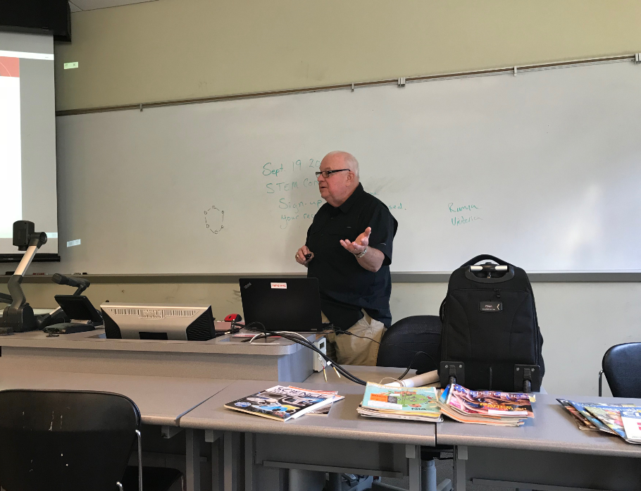
Figure 1: Mr. Dennis Dupps Presenting

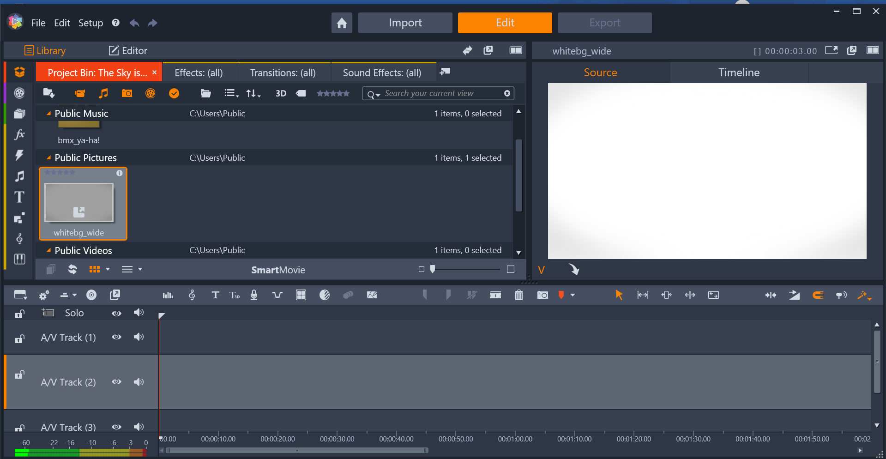

Figure 2: Image of Blank Screen

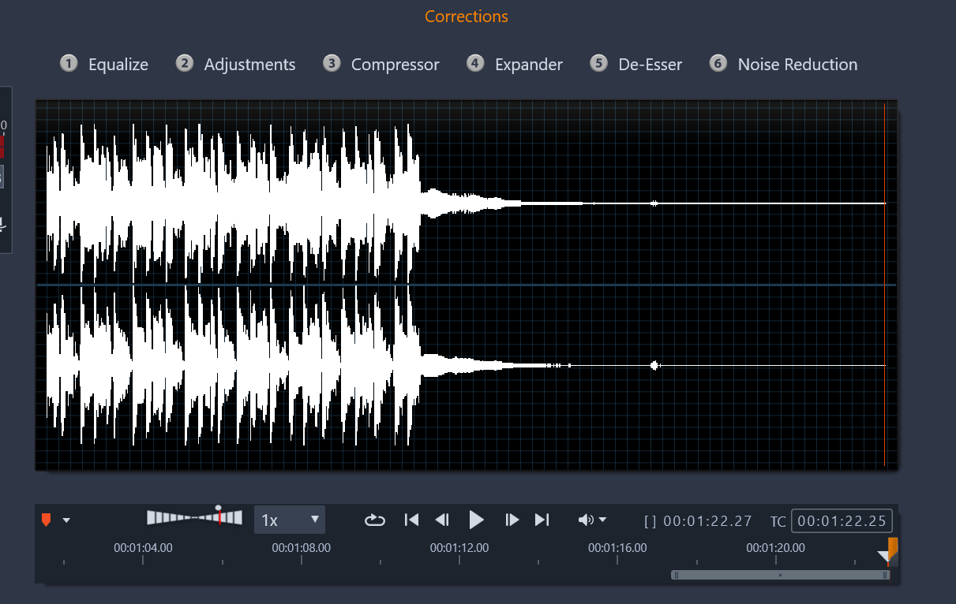

Figure 3: Image of a Screen with Voice Over

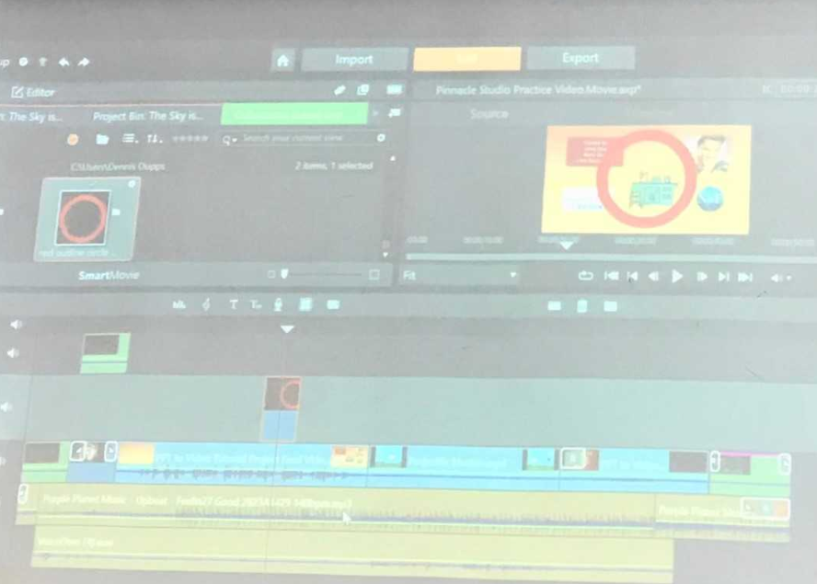

Figure 4: Image of a Completed Screen

Mr. Dupps talked about putting it all together and viewing the whole video. Dennis showed us how to add credits for others and upload to the YouTube. Arial font was recommended because it is simple. Editing video clips were discussed by using the ‘razor blade’, ‘trim’ around it, ‘cut’, and ‘delete’ features.

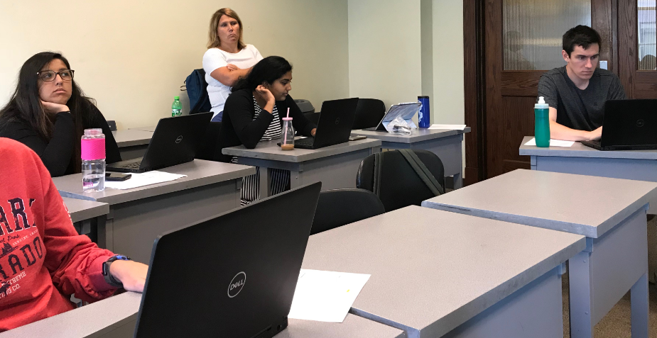

Figure 5: Image of a RET Participants in Tune

About adding music Dennis Dupps stated that adding music is fine, but try to limit to instrumental music to keep distraction minimum. He advised that www.purple-planet.com is a site that contains free music.

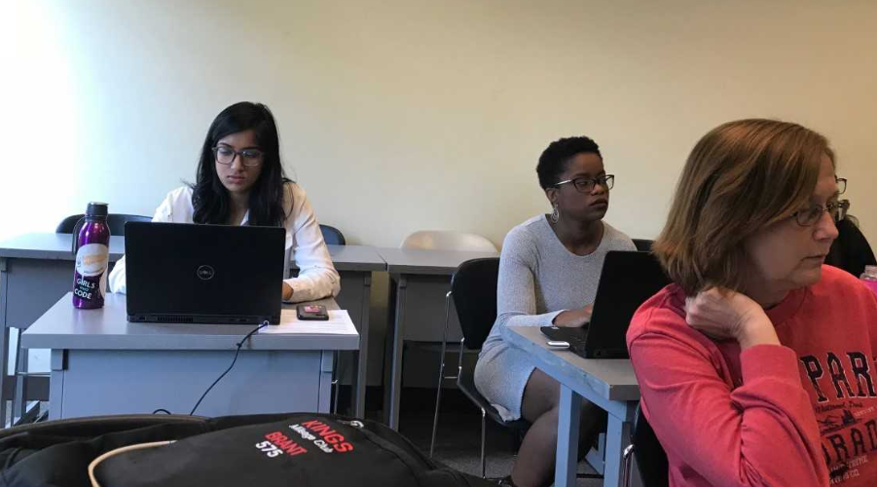

Figure 6: Image of a RET Participants Enjoying the Music

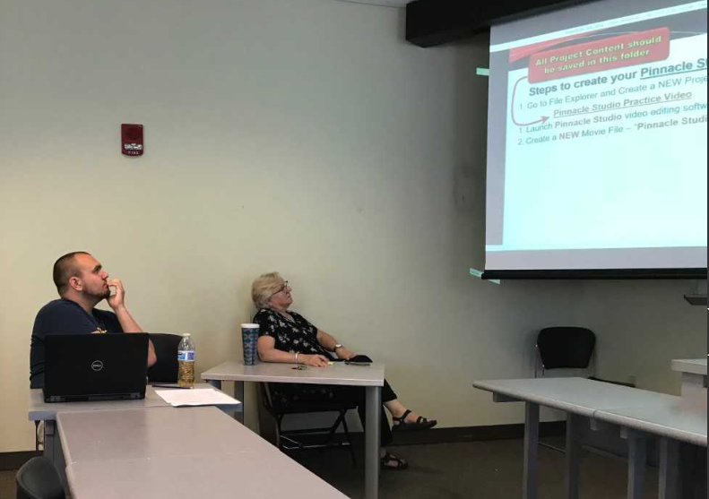

Figure 7: Image of a RET Participants Keenly Following

It was an informative professional development session.

